
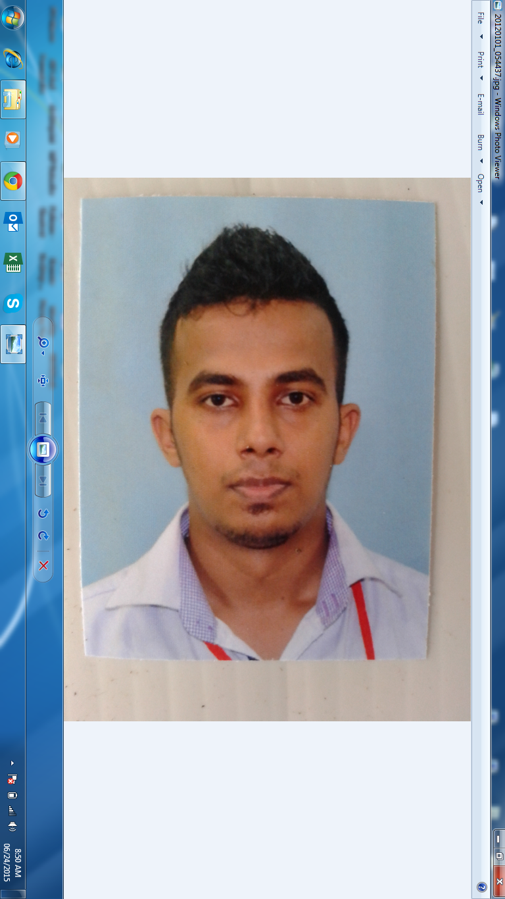
Sinhawalli Arachchige Pathum Tharanga
NO 286/2, Siyabalape North ,Siyabalape.
Contact info: 0771481122.
Pathum@glowbaloutlets.lk
Pathum.TharangaUSL@gmail.com

OBJECTIVE

To get established in the co-operative world to serve the nation and the organization with my knowledge and experience while striving the company and the self success to a newest horizons.
Also, to seek a challenging position in a growth oriented organization where my skills could be utilized to the fullest potential. I’m a hard worker, well organized and have ability to work effectively under pressure in order to meet the deadlines or constraints.
WORKING EXPERIENCES

Overall Have 7 Years’ Experience in Supply Chain Environment (Specially WH Operation / Systematic Operation Planning / ERP System – Qualified in South Asia / WH Admin / Cost Saving / Process streamline)
- Have 4 years’ Experience at LOGIWIZ (PVT) LTD as an Operation Executive / System analyzer / Inventory Auditor & Coordinator of the Replenishment cum distribution model/Operations & Reconciliation factory Production outbound for entire UNILEVER SRILANKA end to end supply chain _Logistics
- Previously Work as a WH Stocks/Sales & Distribution Planner – Unilever cluster end to end
- Have 2 Year Experience at Unilever Sri Lanka Limited as a System & Operation Planner. - Unilever
- 1 & Half year’s Work as a WH Operation / Sales /Distribution & MIS Developing Planner – Unilever
- Have worked as a System & Inventory Management consultant in Brandix Mercury Asia.(Part Time)
- Creating MS Access & MS Excel Database for Operation and improve effectiveness within the value stream
- Currently Work as a “Manager - Supply Chain – (WH Operation & Systematic Operation Planning) ” in Glowbal Outlets (Pvt) Ltd,Katunayake.

- Supporting & creating 100% a safe environment in the Area with high standards of SHE compliance
- High level of operational and hands on knowledge in productivity tools such as ‘5S’ & Quality Control Circles’ in House Keeping.
- Driving best quality practices and QA guide lines in production and warehouse activities including Warehouse best practices
- Currently work with SAP ERP Global ERP ECC 6.1 system and nominated and expert worker as a Super User/Power user
- Super user for the SAP supported modules BIW( Business Information WH) & APO( Advance planning optimizer functions for distribution)
Contributed SAP implementation in Unilever SRILANKA
Successful achievements in user accepting testing in SAP
Prepared SAP Training materials & conducted end user trainings effectively with in the cluster and Warehouses
- Worked with Mfg/Pro & Global MRP(SAP) System as a Super User
Sales & Distribution planning – Unilever SRILANKA
Contributed, Reconcile the inventory in the lead functions as an inventory auditor
Knowledge in Production Reporting & Reconciliation functions

- Planning knowledge in storage Norm & layout According to the sales as well as product categorization while optimizing the capacity of the Distribution center
- Skills in managing the staff
- Preparing review meeting presentations & preparing monthly reports for USL cluster.
- Responsible for tracking the all KPIs of USL cluster to support to achive the inventory accuracy of 99.98 % in PSV

Key Responsibilities which was followed in Hole Career

- Liaise with service providers to get their prompt attendance on services, upgrading, renewals on fire, safety, pest control, security, warehouse maintenance.

- Co-ordination in receiving information about Shipment arrivals
- Co-ordination with suppliers to arrange the transport in order meets the KPI
- Co-ordination with receivers in order to deliver the materials on time
- Handle overall Inventory. (MFGPRO / SAP / Visual Dolphin )
- Monthly invoice statements preparing.
- Preparing cost & revenue reports & send it to the management ,

- Monitoring of KPI towards customer expectation and warehouse arrangements.

- Monitoring Storing incoming shipment in the correct location & maintaining FIFO system when issuing.
- Shipment unloading monitoring.
- Communication with the customer damaged & short cargo (Q /A )
- Monitoring of picking process as per request made by customer
- Following up until materials are delivered to site on time
- Following up the POD (Proof Of Delivery) from transporters & handover to customer on time
- Preparing Monthly KPI reports & sends it to Customer & management.(Monthly KPI as follows)

1.Timely unloading of materials
2.Timely picking of materials
3.Ontime delivery.
4.Truck fill Rate
5.Inventory accuracy
6.Ontime POD hand over to the Customer
7.Back order ( CCFOT DATA –Customer Cases Fill On Time )
8. Replenishment on Time

- Constant reporting on staff attendance and communication with staff on their leaves and other administrative requirement.

- Work towards KPIs with team members
- Manage the allocation of appropriate resources and commitment of staff to the achievement of objectives and targets of the department
- Identify training needs, performances of the team and report to the management

Past Employment

- I have worked as a F & B Service Officer at Athula Caterers pvt ltd. ( 2008-2009 )
- I have worked as a WH/Operation / Sales & Distribution Planner at LOGIWIZ (PVT) LTD. ( 2010-2013 )
- Have Worked 1 & Half Year as a WH Operation / Sales /Distribution & MIS Developing Planner at Unilever ( 2013 to 2014)
- Have worked 1 year as a System & Inventory Management consultant in Brandix Mercury Asia.(Part Time)

HIGHER EDUCATIONAL QUALIFICATION

- Currently Following Professional Diploma in Logistics Management – NIBM Campus

- Core Modules
  - Enterprise Resource Planning (ERP)
  - Supply Chain Management
  - Warehouse Management
  - Transportation & Networking
  - Quality Systems & Service Quality
  - Maintenance Management
  - Order Processing & Information Systems
  - Logistics Audit & Control
  - Import & Export Management
- Supplementary Modules
  - Marketing Logistics
  - Advanced Financial Management
  - Human Resource Management in Logistics
  - Independent Project on Business Process Improvement
- Successfully completed Computer certificate course of 3D Animation & graphic with MS Office Package designing.

- Followed and merit pass Stores Management (Basic Diploma) in Institute of Supply & material Management (English Medium) 2012. Under below curriculums
- Introduction of Stores Management
- Planning, Sitting and layout of Stores Building and Stock yards
- Stores Organization and Staff
- Supply Cycle
- Purchasing Functions
- Control of Receipts
- Control of Issues
- Control of Dispatch
- Distribution
- Storage Methods and Location
- Storage Equipment
- Maintenance, Preservation & Protection of Storage
- Materials Handling
- Stock Control
- Stores Accounts
- Planning, Organization, Control, Management Functions
- Motivation, Productivity, Leadership, Communication
- Disposal of Unserviceable and write offs
- Stock Verification
- Stock Records
- Coding and Classification
- Stores Manual
- Packing and Packaging
- Purchase of Capital Equipment
- Standardization
- Specifications
- Fire and Security Aspects
- Return Stores, Transfers
- Duties and Responsibilities of Stores Managers
- Quality Control.

EXTRA CURRICULAR ACTIVITIES

- A Member of Gurukula College Senior Prefect Team.

- A Member of Gurukula College Media Unit 2007-2009.

- A Member of Gurukula College Senior Prefect Cricket Team.

- Participated in International Karate Tournament in Sri Lnka 2005-2009.

- A Leader of Traffic Warden Unit of Gurukula College in 2003-2009.

PERSONAL DETAILS

- NAME IN FULL : Sinhawalli Arachchige Pathum Tharanga
- DATE OF BIRTH : 05th May 1990
- SEX : Male
- CIVIL STATUS : Married
- NIC NO : 901262055 v
- NATIONALITY : Sinhala
- SCHOOL ATTENDS: Gurukula Central College, Kelaniya.

EDUCATIONAL QULIFICATION

G.C.E. O/L Examination – 2006

Subject Grade

Social studies B
Art C
Commerce B
Subject Grade

SinhalaCember of a School cadet Platon by C.P.L
hara.
EnglishS
BuddhismA
MathematicsB
ScienceB

G.C.E. A/L Examination – 2009

I hereby certify that the above particulars given by me are true and accurate to the best of my knowledge.
Subject Grade

Physics S

Chemistry S

General English S

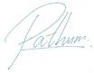

Thank you & Warm Regard,
Pathum Tharanga
……………………………
Date

REFEREE

Krishon Migara
Senior Panning Manager
Unilever Sri Lanka Limited.

Tel: +94 11 470 0800
Mob: +94 777 371 052
Keembiyage.Migara@unilever.com

Subash George
Senior Manager – WH Operation
Hayleys Group

Tel: +94 77 30 33 542

